**CSA1518-CLOUD COMPUTING**

T. Ashwath

192011375

**Expt:9**

Create a Snapshot of a VM and Test it by loading the Previous Version/Cloned VM

**IMPLEMENTATION:**

STEP 1: OPEN VMWARE AND CREATE NEW VIRTUAL MACHINE

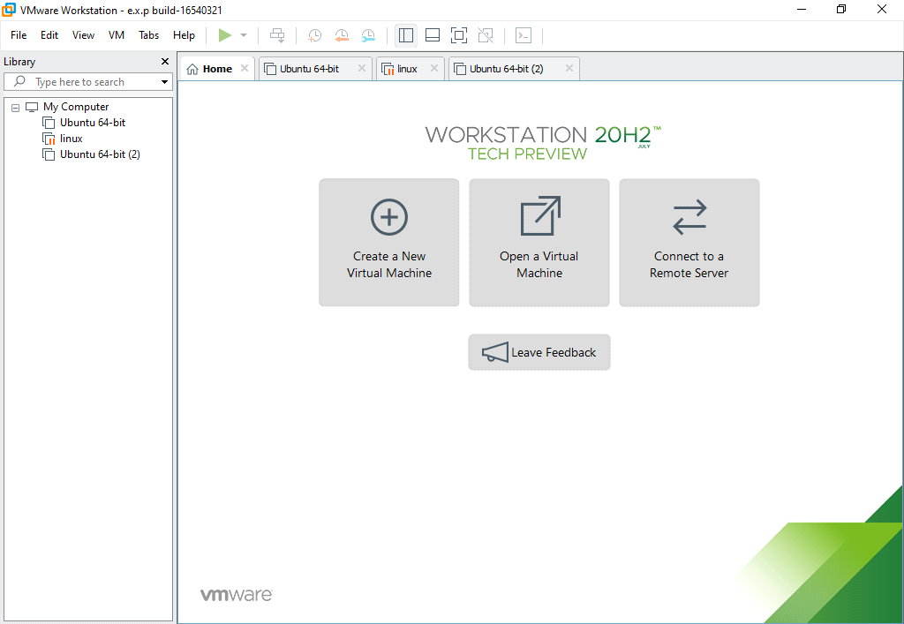

STEP 2: GOTO VMWARE WORKSTATION AND SELECT ANY VM

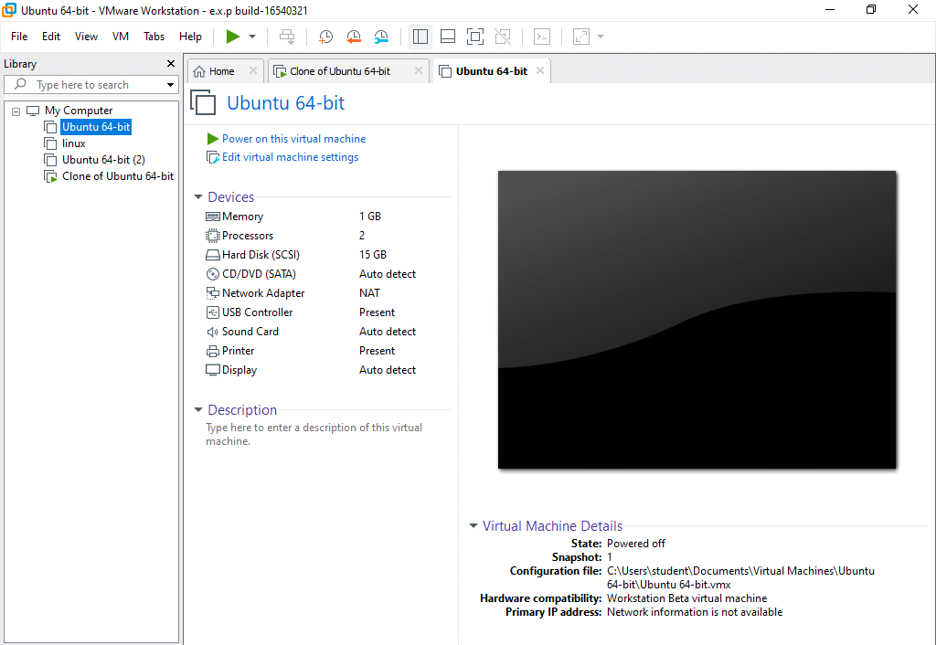

STEP 2:CLICK ON VM AND SELECTS SNAPSHOT-> TAKE SNAPSHOT 1

STEP 3:CHANGE PROCESSOR NUMBER AND TAKE SNAPSHOT 2

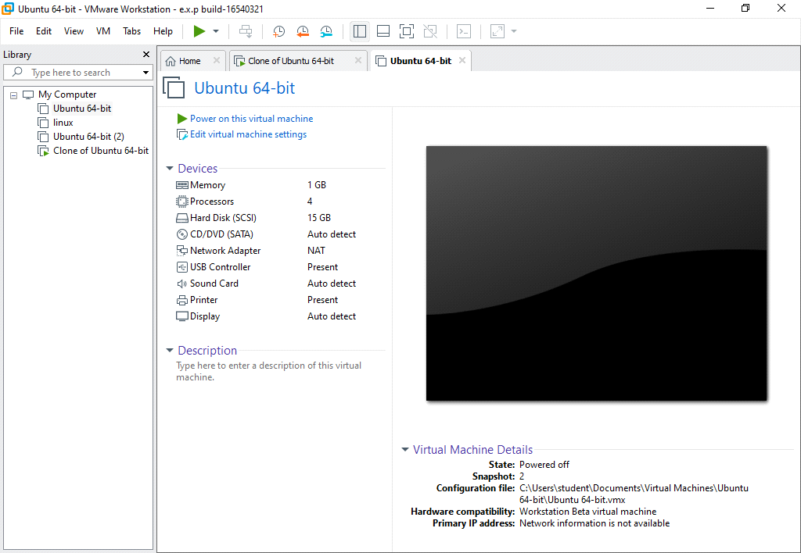

STEP 3:CHANGE MEMORY SIZE AND TAKE SNAPSHOT 3

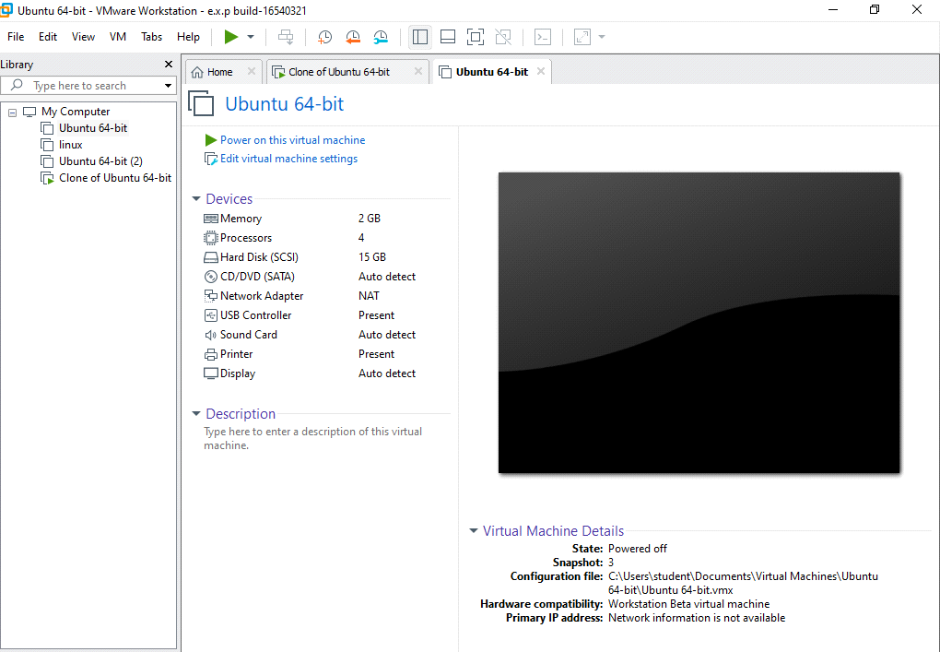

STEP 4:REVERT BACK TO SNAP SHOT 2

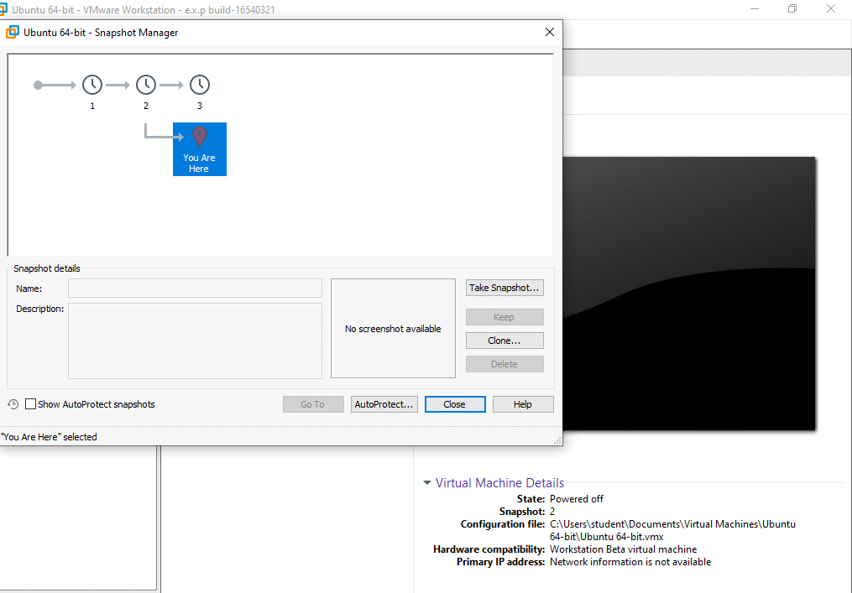

STEP 5:GO TO SNAP SHOT MANAGER

OUTPUT

